# Spark综合案例-概述

## 流程分析

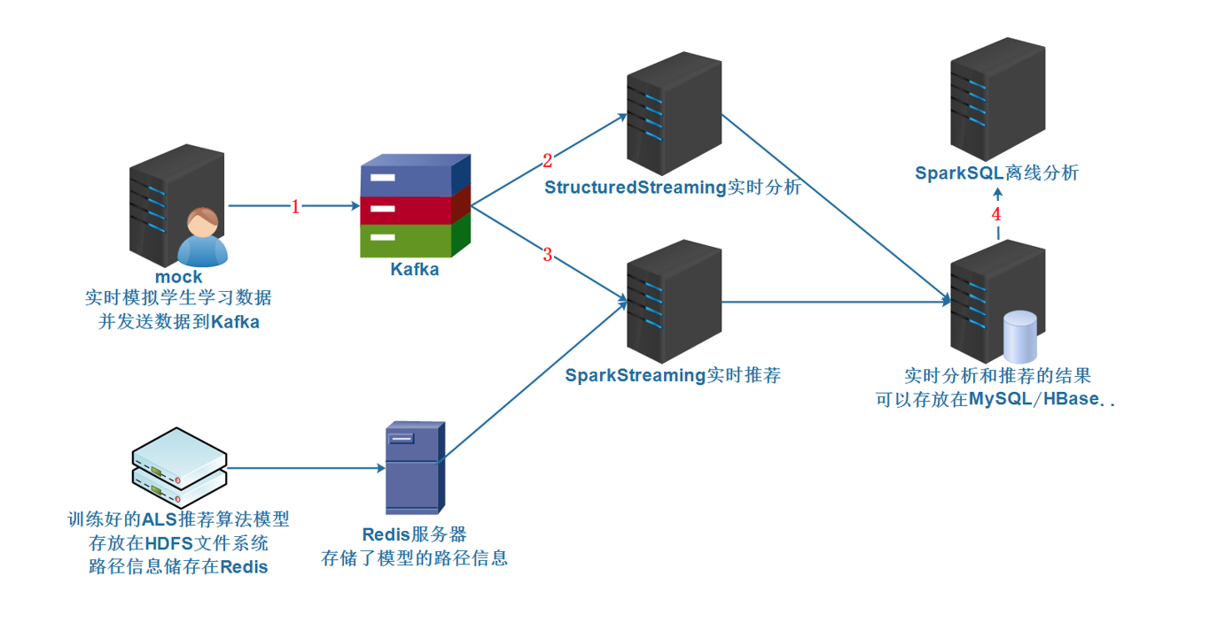

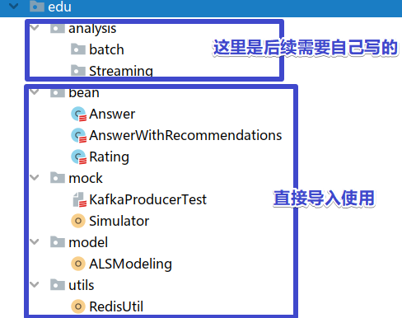

## 准备Kafka主题

#查看topic信息  
/export/server/kafka/bin/kafka-topics.sh --list --zookeeper node1:2181  
  
#删除topic  
/export/server/kafka/bin/kafka-topics.sh --delete --zookeeper node1:2181 --topic edu  
  
#创建topic  
/export/server/kafka/bin/kafka-topics.sh --create --zookeeper node1:2181 --replication-factor 1 --partitions 3 --topic edu  
  
#模拟消费者  
/export/server/kafka/bin/kafka-console-consumer.sh --bootstrap-server node1:9092 --topic edu --from-beginning

## 测试发送数据到Kafka

启动

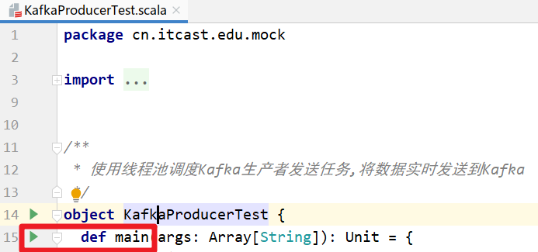

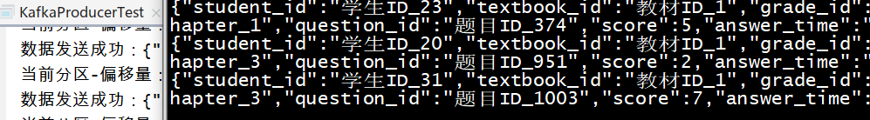

{  
 "student_id":"学生ID_31",  
 "textbook_id":"教材ID_1",  
 "grade_id":"年级ID_6",  
 "subject_id":"科目ID_2_语文",  
 "chapter_id":"章节ID_chapter_3",  
 "question_id":"题目ID_1003",  
 "score":7,  
 "answer_time":"2021-01-09 14:53:28",  
 "ts":"Jan 9, 2021 2:53:28 PM"  
}

# 学生答题情况实时分析

## 需求

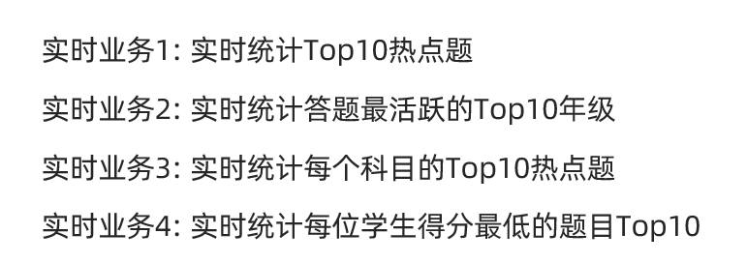

## 代码实现

package com.as.edu.analysis.streaming  
  
import com.as.edu.bean.Answer  
import com.google.gson.Gson  
import org.apache.spark.SparkContext  
import org.apache.spark.sql.{DataFrame, Dataset, Row, SparkSession}  
  
/**  
 * Author roy  
 * Desc 实时的从Kafka的edu主题消费数据,并做实时的统计分析,结果可以直接输出到控制台或mysql  
 */  
object StreamingAnalysis {  
 def main(args: Array[String]): Unit = {  
 //TODO 0.准备环境  
 val spark: SparkSession = SparkSession.builder().appName("StreamingAnalysis").master("local[*]")  
 .config("spark.sql.shuffle.partitions", "4")//本次测试时将分区数设置小一点,实际开发中可以根据集群规模调整大小,默认200  
 .getOrCreate()  
 val sc: SparkContext = spark.sparkContext  
 sc.setLogLevel("WARN")  
 import spark.implicits._  
 import org.apache.spark.sql.functions._  
  
 //TODO 1.加载数据  
 val kafkaDF: DataFrame = spark.readStream  
 .format("kafka")  
 .option("kafka.bootstrap.servers", "node1:9092")  
 .option("subscribe", "edu")  
 .load()  
 val valueDS: Dataset[String] = kafkaDF.selectExpr("CAST(value AS STRING)").as[String]  
 //{"student_id":"学生ID_31","textbook_id":"教材ID_1","grade_id":"年级ID_6","subject_id":"科目ID_2_语文","chapter_id":"章节ID_chapter_3","question_id":"题目ID_1003","score":7,"answer_time":"2021-01-09 14:53:28","ts":"Jan 9, 2021 2:53:28 PM"}  
  
 //TODO 2.处理数据  
 //---数据预处理  
 //解析json-方式1:  
 /*valueDS.select(  
 get_json_object($"value", "$.student_id").as("student_id"),  
 //.....  
 )*/  
 //解析json-方式2:将每一条json字符串解析为一个样例类对象  
 val answerDS: Dataset[Answer] = valueDS.map(josnStr => {  
 val gson = new Gson()  
 //json--->对象  
 gson.fromJson(josnStr, classOf[Answer])  
 })  
 //---实时分析  
 //TODO ==实时分析需求1:统计top10热点题  
 //SQL  
 /*  
 val result1 = spark.sql(  
 """SELECT  
 | question_id, COUNT(1) AS frequency  
 |FROM  
 | t_answer  
 |GROUP BY  
 | question_id  
 |ORDER BY  
 | frequency  
 |DESC  
 |LIMIT 10  
 """.stripMargin)  
 */  
 //DSL  
 val result1: Dataset[Row] = answerDS.groupBy('question_id)  
 //.agg(count('question_id) as "count")  
 .count()  
 .orderBy('count.desc)  
 .limit(10)  
  
 //TODO ==实时分析需求2:统计top10答题活跃年级  
 /*  
 val result2 = spark.sql(  
 """SELECT  
 | grade_id, COUNT(1) AS frequency  
 |FROM  
 | t_answer  
 |GROUP BY  
 | grade_id  
 |ORDER BY  
 | frequency  
 |DESC  
 |LIMIT 10  
 """.stripMargin)  
 */  
 val result2: Dataset[Row] = answerDS.groupBy('grade_id)  
 .count()  
 .orderBy('count.desc)  
 .limit(10)  
  
 //TODO ==实时分析需求3:统计top10热点题并带上所属科目  
 /*  
 注意:select...group语句下,select 后面的字段要么是分组字段,要么是聚合字段  
 val result1 = spark.sql(  
 """SELECT  
 | question_id,first(subject_id), COUNT(1) AS frequency  
 |FROM  
 | t_answer  
 |GROUP BY  
 | question_id  
 |ORDER BY  
 | frequency  
 |DESC  
 |LIMIT 10  
 """.stripMargin)  
 */  
 val result3: Dataset[Row] = answerDS.groupBy('question_id)  
 .agg(  
 first('subject_id) as "subject_id",  
 count('question_id) as "count"  
 )  
 .orderBy('count.desc)  
 .limit(10)  
  
 //TODO ==实时分析需求4:统计每个学生的得分最低的题目top10并带上是所属哪道题  
 /*  
 val result4 = spark.sql(  
 """SELECT  
 | student_id, FIRST(question_id), MIN(score)  
 |FROM  
 | t_answer  
 |GROUP BY  
 | student_id  
 |order by  
 | score  
 |limit 10  
 """.stripMargin)  
 */  
 val result4: Dataset[Row] = answerDS.groupBy('student_id)  
 .agg(  
 min('score) as "minscore",  
 first('question_id)  
 )  
 .orderBy('minscore)  
 .limit(10)  
  
  
 //TODO 3.输出结果  
 result1.writeStream  
 .format("console")  
 .outputMode("complete")  
 .start()  
 result2.writeStream  
 .format("console")  
 .outputMode("complete")  
 .start()  
 result3.writeStream  
 .format("console")  
 .outputMode("complete")  
 .start()  
 result4.writeStream  
 .format("console")  
 .outputMode("complete")  
 //TODO 4.启动并等待结束  
 .start()  
 .awaitTermination()  
  
 //TODO 5.关闭资源  
 spark.stop()  
 }  
}

# 实时推荐易错题

## 需求

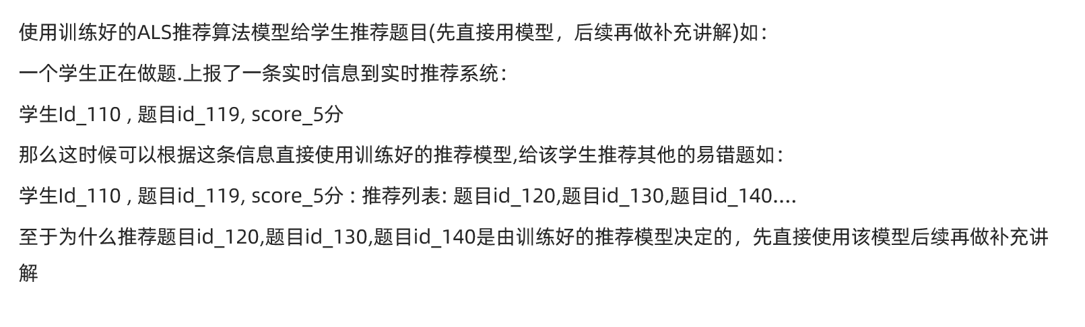

## 准备模型-直接训练并使用

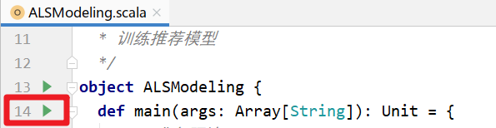

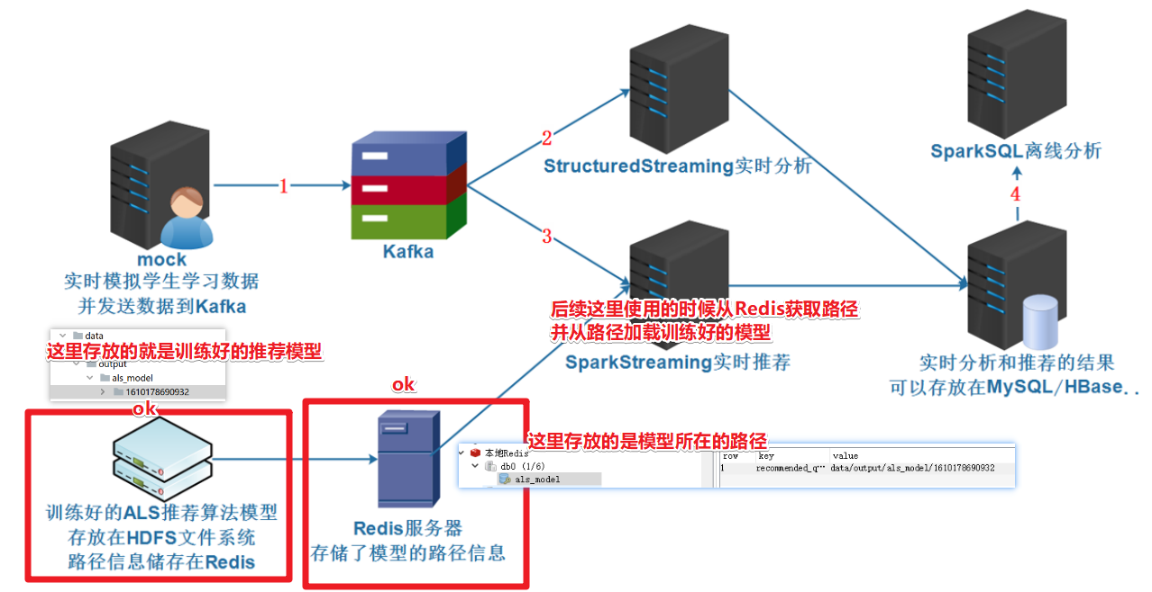

## 代码实现

package com.as.edu.analysis.streaming  
  
import com.as.edu.bean.Answer  
import com.as.edu.utils.RedisUtil  
import com.google.gson.Gson  
import org.apache.kafka.clients.consumer.ConsumerRecord  
import org.apache.kafka.common.serialization.StringDeserializer  
import org.apache.spark.ml.recommendation.ALSModel  
import org.apache.spark.{SparkContext, streaming}  
import org.apache.spark.sql.{DataFrame, SaveMode, SparkSession}  
import org.apache.spark.streaming.dstream.{DStream, InputDStream}  
import org.apache.spark.streaming.kafka010.{ConsumerStrategies, KafkaUtils, LocationStrategies}  
import org.apache.spark.streaming.{Seconds, StreamingContext}  
import redis.clients.jedis.Jedis  
  
/**  
 * Author roy  
 * Desc  
 * 从Kafka消费消息(消息中有用户id),  
 * 然后从Redis中获取推荐模型的路径,并从路径中加载推荐模型ALSModel  
 * 然后使用该模型给用户推荐易错题  
 */  
object StreamingRecommend {  
 def main(args: Array[String]): Unit = {  
 //TODO 0.准备环境  
 val spark: SparkSession = SparkSession.builder().appName("StreamingAnalysis").master("local[*]")  
 .config("spark.sql.shuffle.partitions", "4") //本次测试时将分区数设置小一点,实际开发中可以根据集群规模调整大小,默认200  
 .getOrCreate()  
 val sc: SparkContext = spark.sparkContext  
 sc.setLogLevel("WARN")  
 val ssc: StreamingContext = new StreamingContext(sc, streaming.Seconds(5))  
 import spark.implicits._  
 import org.apache.spark.sql.functions._  
  
 //TODO 1.加载数据  
 val kafkaParams = Map[String, Object](  
 "bootstrap.servers" -> "node1:9092", //kafka集群地址  
 "key.deserializer" -> classOf[StringDeserializer], //key的反序列化规则  
 "value.deserializer" -> classOf[StringDeserializer], //value的反序列化规则  
 "group.id" -> "StreamingRecommend", //消费者组名称  
 "auto.offset.reset" -> "latest",  
 "auto.commit.interval.ms" -> "1000", //自动提交的时间间隔  
 "enable.auto.commit" -> (true: java.lang.Boolean) //是否自动提交  
 )  
 val topics = Array("edu") //要订阅的主题  
 val kafkaDStream: InputDStream[ConsumerRecord[String, String]] = KafkaUtils.createDirectStream[String, String](ssc,  
 LocationStrategies.PreferConsistent,  
 ConsumerStrategies.Subscribe[String, String](topics, kafkaParams)  
 )  
  
 //TODO 2.处理数据  
 val valueDStream: DStream[String] = kafkaDStream.map(record => {  
 record.value()  
 })  
 //{"student_id":"学生ID_47","textbook_id":"教材ID_1","grade_id":"年级ID_3","subject_id":"科目ID_3_英语","chapter_id":"章节ID_chapter_3","question_id":"题目ID_534","score":7,"answer_time":"2021-01-09 15:29:50","ts":"Jan 9, 2021 3:29:50 PM"}  
 valueDStream.foreachRDD(rdd => {  
 if (!rdd.isEmpty()) {  
  
 //该rdd表示每个微批的数据  
 //==1.获取path并加载模型  
 //获取redis连接  
 val jedis: Jedis = RedisUtil.pool.getResource  
 //加载模型路径  
 // jedis.hset("als_model", "recommended_question_id", path)  
 val path: String = jedis.hget("als_model", "recommended_question_id")  
 //根据路径加载模型  
 val model: ALSModel = ALSModel.load(path)  
  
 //==2.取出用户id  
 val answerDF: DataFrame = rdd.coalesce(1).map(josnStr => {  
 val gson = new Gson()  
 gson.fromJson(josnStr, classOf[Answer])  
 }).toDF  
 //将用户id转为数字,因为后续模型推荐的时候需要数字格式的id  
 val id2int = udf((student_id: String) => {  
 student_id.split("_")(1).toInt  
 })  
 val studentIdDF: DataFrame = answerDF.select(id2int('student_id) as "student_id")  
  
 //==3.使用模型给用户推荐题目  
 val recommendDF: DataFrame = model.recommendForUserSubset(studentIdDF, 10)  
 recommendDF.printSchema()  
 /*  
 root  
 |-- student_id: integer (nullable = false) --用户id  
 |-- recommendations: array (nullable = true)--推荐列表  
 | |-- element: struct (containsNull = true)  
 | | |-- question_id: integer (nullable = true)--题目id  
 | | |-- rating: float (nullable = true)--评分/推荐指数  
 */  
 recommendDF.show(false)  
 /*  
 +----------+--------------------------------------------------------------------------------------------------------------------------------------------------------------------------------------------+  
 |student_id|recommendations |  
 +----------+--------------------------------------------------------------------------------------------------------------------------------------------------------------------------------------------+  
 |12 |[[1707, 2.900552], [641, 2.8934805], [815, 2.8934805], [1583, 2.8934805], [1585, 2.8774242], [1369, 2.8033295], [906, 2.772558], [2129, 2.668791], [1661, 2.585957], [1978, 2.5290453]] |  
 |14 |[[1627, 2.8925943], [446, 2.8925943], [1951, 2.8925943], [1412, 2.8925943], [1812, 2.8925943], [1061, 2.8816805], [1661, 2.874632], [1453, 2.8682063], [1111, 2.8643343], [1797, 2.7966104]]|  
 */  
 //处理推荐结果:取出用户id和题目id拼成字符串:"id1,id2,id3..."  
 val recommendResultDF: DataFrame = recommendDF.as[(Int, Array[(Int, Float)])].map(t => {  
 //val studentId: Int = t._1  
 //val studentIdStr: String = "学生ID_"+ studentId  
 //val questionIdsAndRating: Array[(Int, Float)] = t._2  
 //val questionIds: Array[Int] = questionIdsAndRating.map(_._1)  
 //val questionIdsStr: String = questionIds.mkString(",")  
 val studentIdStr: String = "学生ID_" + t._1  
 val questionIdsStr: String = t._2.map("题目ID_" + _._1).mkString(",")  
 (studentIdStr, questionIdsStr)  
 }).toDF("student_id", "recommendations")  
  
 //将answerDF和recommendResultDF进行join  
 val allInfoDF: DataFrame = answerDF.join(recommendResultDF, "student_id")  
  
 //==4.输出结果到MySQL/HBase  
 if (allInfoDF.count() > 0) {  
 val properties = new java.util.Properties()  
 properties.setProperty("user", "root")  
 properties.setProperty("password", "root")  
 allInfoDF  
 .write  
 .mode(SaveMode.Append)  
 .jdbc("jdbc:mysql://localhost:3306/edu?useUnicode=true&characterEncoding=utf8", "t_recommended", properties)  
 }  
  
 //关闭redis连接  
 jedis.close()  
 }  
 }  
 )  
  
 //TODO 3.输出结果  
  
 //TODO 4.启动并等待停止  
 ssc.start()  
 ssc.awaitTermination()  
  
 //TODO 5.关闭资源  
 ssc.stop(stopSparkContext = true, stopGracefully = true) //优雅关闭  
 }  
  
}

# 学生答题情况离线分析

## 需求

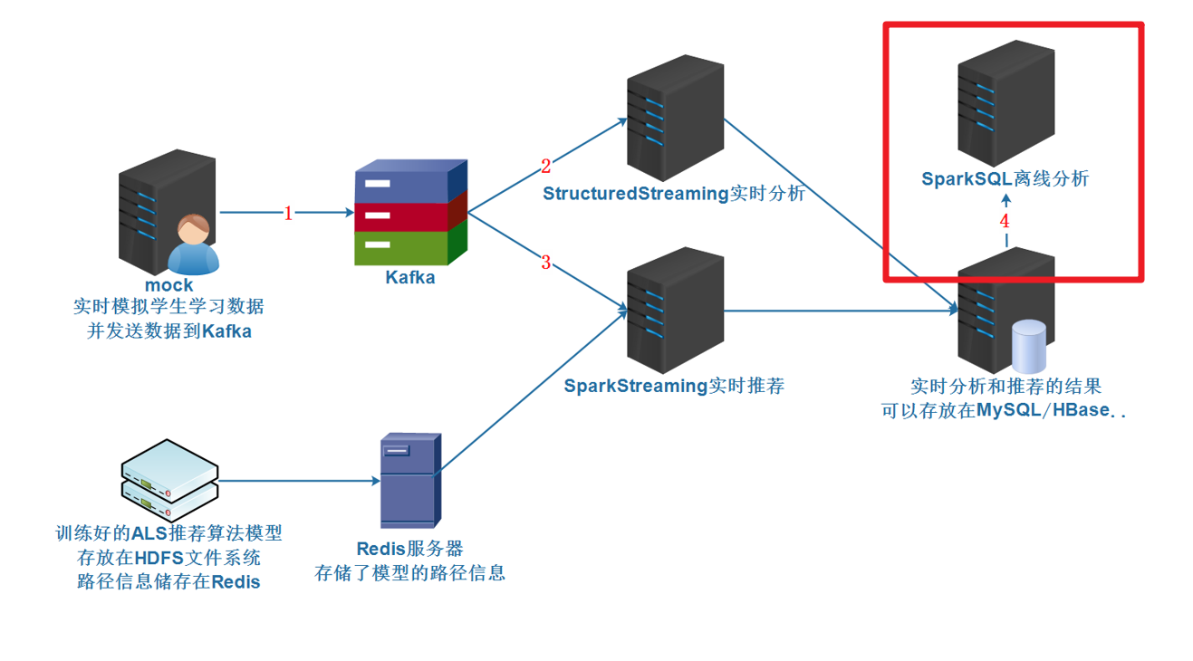

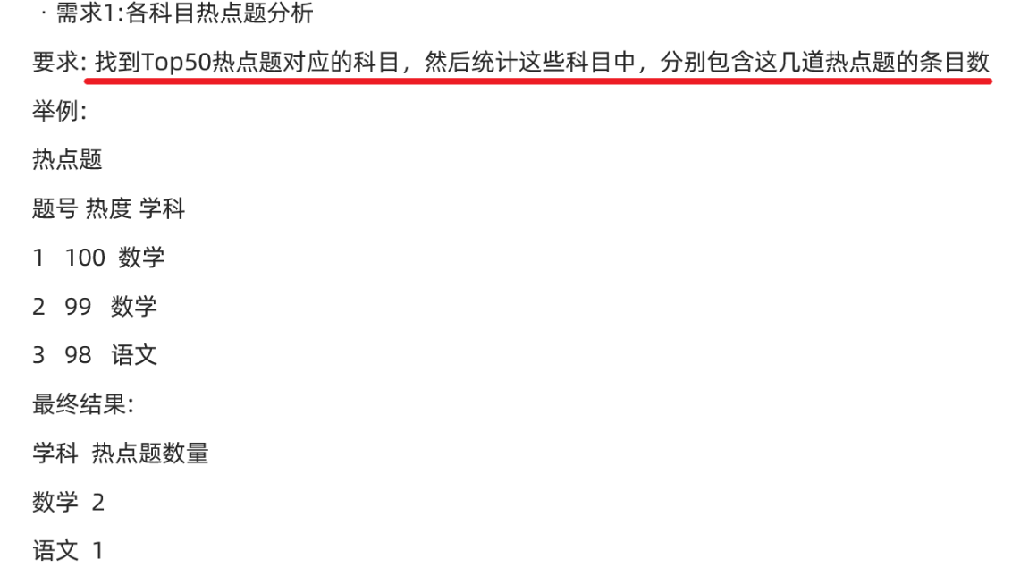

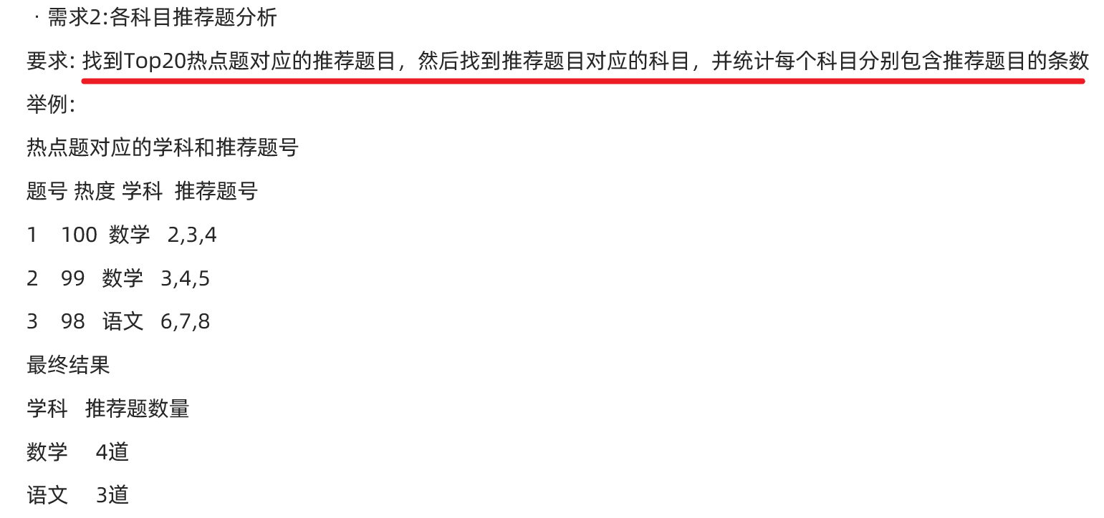

## 代码实现

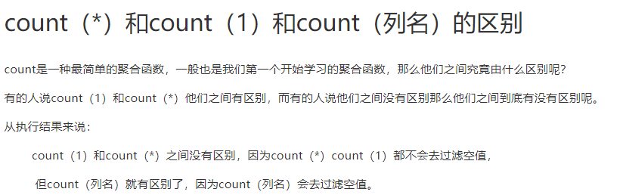

package com.as.edu.analysis.batch  
  
import breeze.linalg.*  
import com.as.edu.bean.AnswerWithRecommendations  
import org.apache.spark.SparkContext  
import org.apache.spark.sql.{DataFrame, Dataset, Row, SparkSession}  
  
/**  
 * Author roy  
 * Desc 离线分析学生学习情况  
 */  
object BatchAnalysis {  
 def main(args: Array[String]): Unit = {  
 //TODO 0.准备环境-SparkSession  
 val spark: SparkSession = SparkSession.builder().appName("BatchAnalysis").master("local[*]")  
 .config("spark.sql.shuffle.partitions", "4")//本次测试时将分区数设置小一点,实际开发中可以根据集群规模调整大小,默认200  
 .getOrCreate()  
 val sc: SparkContext = spark.sparkContext  
 sc.setLogLevel("WARN")  
 import spark.implicits._  
 import org.apache.spark.sql.functions._  
  
 //TODO 1.加载数据-MySQL  
 val properties = new java.util.Properties()  
 properties.setProperty("user", "root")  
 properties.setProperty("password", "root")  
 val allInfoDS: Dataset[AnswerWithRecommendations] = spark.read.jdbc(  
 "jdbc:mysql://localhost:3306/edu?useUnicode=true&characterEncoding=utf8",  
 "t_recommended",  
 properties  
 ).as[AnswerWithRecommendations]  
  
 //TODO 2.处理数据/分析数据  
 //TODO ===SQL  
 //TODO: 需求:1.各科目热点题分析  
 // 找到Top50热点题对应的科目，然后统计这些科目中，分别包含这几道热点题的条目数  
 /*  
 题号 热度  
 1 10  
 2 9  
 3 8  
 */  
 /*  
 题号 热度 科目  
 1 10 语文  
 2 9 数学  
 3 8 数学  
 */  
 /*  
 科目 热点题数量  
 语文 1  
 数学 2  
 */  
 //1.统计Top50热点题--子查询t1  
 //2.将t1和原始表t_answer关联,并按学科分组聚合统计各个学科包含的热点题的数量  
 //==================写法1:SQL风格================  
 /*spark.sql(  
 """SELECT  
 | subject_id, count(t_answer.question_id) AS hot_question_count  
 | FROM  
 | (SELECT  
 | question_id, count(*) AS frequency  
 | FROM  
 | t_answer  
 | GROUP BY  
 | question_id  
 | ORDER BY  
 | frequency  
 | DESC LIMIT  
 | 50) t1  
 |JOIN  
 | t_answer  
 |ON  
 | t1.question_id = t_answer.question_id  
 |GROUP BY  
 | subject_id  
 |ORDER BY  
 | hot_question_count  
 | DESC  
 """.stripMargin)  
 .show()*/  
  
 //TODO: 需求:2.各科目推荐题分析  
 // 找到Top20热点题对应的推荐题目，然后找到推荐题目对应的科目，并统计每个科目分别包含推荐题目的条数  
 /*  
 科目,包含的推荐的题目的数量  
 英语,105  
 语文,95  
 数学,89  
 */  
 //1.统计热点题Top20--子查询t1  
 //2.将t1和原始表t_answer关联,得到热点题Top20的推荐题列表t2  
 //3.用SPLIT将recommendations中的ids用","切为数组,然后用EXPLODE将列转行,并记为t3  
 //4.对推荐的题目进行去重,将t3和t_answer原始表进行join,得到每个推荐的题目所属的科目,记为t4  
 //5.统计各个科目包含的推荐的题目数量并倒序排序(已去重)  
 //==================写法1:SQL风格================  
 /*spark.sql(  
 """SELECT  
 | t4.subject_id,  
 | COUNT(*) AS frequency  
 |FROM  
 | (SELECT  
 | DISTINCT(t3.question_id),  
 | t_answer.subject_id  
 | FROM  
 | (SELECT  
 | EXPLODE(SPLIT(t2.recommendations, ',')) AS question_id  
 | FROM  
 | (SELECT  
 | recommendations  
 | FROM  
 | (SELECT  
 | question_id,  
 | COUNT(*) AS frequency  
 | FROM  
 | t_answer  
 | GROUP BY  
 | question_id  
 | ORDER BY  
 | frequency  
 | DESC LIMIT  
 | 20) t1  
 | JOIN  
 | t_answer  
 | ON  
 | t1.question_id = t_answer.question_id) t2) t3  
 | JOIN  
 | t_answer  
 | ON  
 | t3.question_id = t_answer.question_id) t4  
 |GROUP BY  
 | t4.subject_id  
 |ORDER BY  
 | frequency  
 |DESC  
 """.stripMargin)  
 .show*/  
  
 //TODO ===DSL  
 //TODO: 需求:1.各科目热点题分析  
 // 找到Top50热点题对应的科目，然后统计这些科目中，分别包含这几道热点题的条目数  
 /*  
 题号 热度  
 1 10  
 2 9  
 3 8  
 */  
 /*  
 题号 热度 科目  
 1 10 语文  
 2 9 数学  
 3 8 数学  
 */  
 /*  
 科目 热点题数量  
 语文 1  
 数学 2  
 */  
 //1.统计Top50热点题--子查询t1  
 val hotTop50: Dataset[Row] = allInfoDS.groupBy('question_id)  
 .agg(count("*") as "hot")  
 .orderBy('hot.desc)  
 .limit(50)  
 //2.将t1和原始表t_answer关联,得到热点题对应的科目  
 val joinDF: DataFrame = hotTop50.join(allInfoDS.dropDuplicates("question_id"),"question_id")  
 //3.按学科分组聚合统计各个学科包含的热点题的数量  
 val result1: Dataset[Row] = joinDF.groupBy('subject_id)  
 .agg(count("*") as "hotCount")  
 .orderBy('hotCount.desc)  
  
 //TODO: 需求:2.各科目推荐题分析  
 // 找到Top20热点题对应的推荐题目，然后找到推荐题目对应的科目，并统计每个科目分别包含推荐题目的条数  
 /*  
 题号 热度  
 1 10  
 2 9  
 题号 热度 推荐题  
 1 10 2,3,4  
 2 9 3,4,5  
 推荐题 科目  
 2 数学  
 3 数学  
 4 物理  
 5 化学  
 科目 推荐题数量  
 数学 2  
 物理 1  
 化学 1  
 */  
 //1.统计热点题Top20--子查询t1  
 val hotTop20: Dataset[Row] = allInfoDS.groupBy('question_id)  
 .agg(count("*") as "hot")  
 .orderBy('hot.desc)  
 .limit(20)  
 //2.将t1和原始表t_answer关联,得到热点题Top20的推荐题列表t2  
 val ridsDF: DataFrame = hotTop20.join(allInfoDS, "question_id")  
 .select("recommendations")  
  
 //3.用SPLIT将recommendations中的ids用","切为数组,然后用EXPLODE将列转行,并记为t3  
 val ridsDS: Dataset[Row] = ridsDF.select(explode(split('recommendations, ",")) as "question_id")  
 .dropDuplicates("question_id")  
 //4.对推荐的题目进行去重,将t3和t_answer原始表进行join,得到每个推荐的题目所属的科目,记为t4  
 //df1.join(df2, $"df1Key" === $"df2Key")  
 //df1.join(df2).where($"df1Key" === $"df2Key")  
 val ridAndSid: DataFrame = ridsDS.join(allInfoDS.dropDuplicates("question_id"),"question_id")  
 //5.统计各个科目包含的推荐的题目数量并倒序排序(已去重)  
 val result2: Dataset[Row] = ridAndSid.groupBy('subject_id)  
 .agg(count("*") as "rcount")  
 .orderBy('rcount.desc)  
  
 //TODO 3.输出结果  
 //result1.show()  
 result2.show()  
  
 //TODO 4.关闭资源  
 spark.stop()  
 }  
}

# 机器学习-科普

http://duilian.msra.cn/app/couplet.aspx

## 人工智能-机器学习名词科普

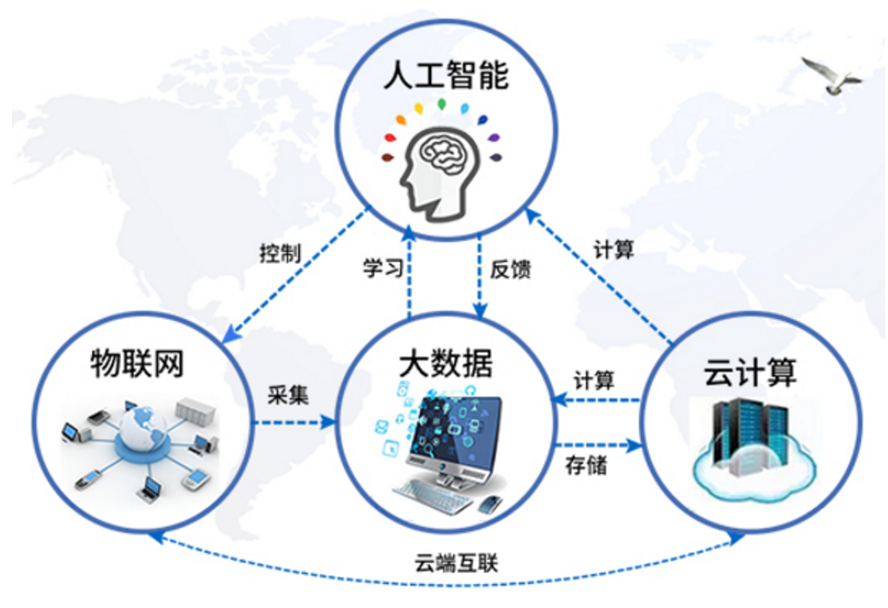

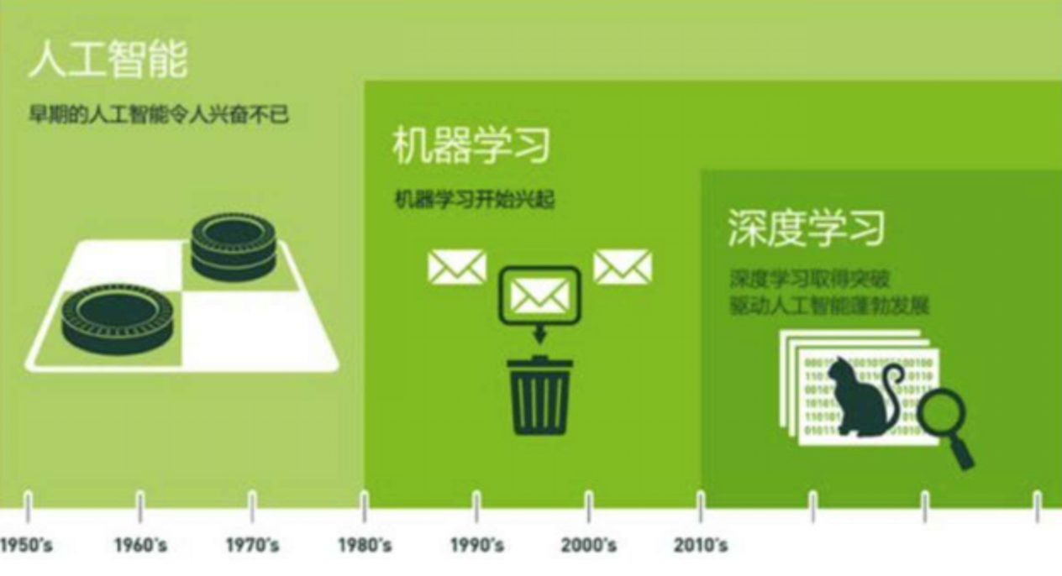

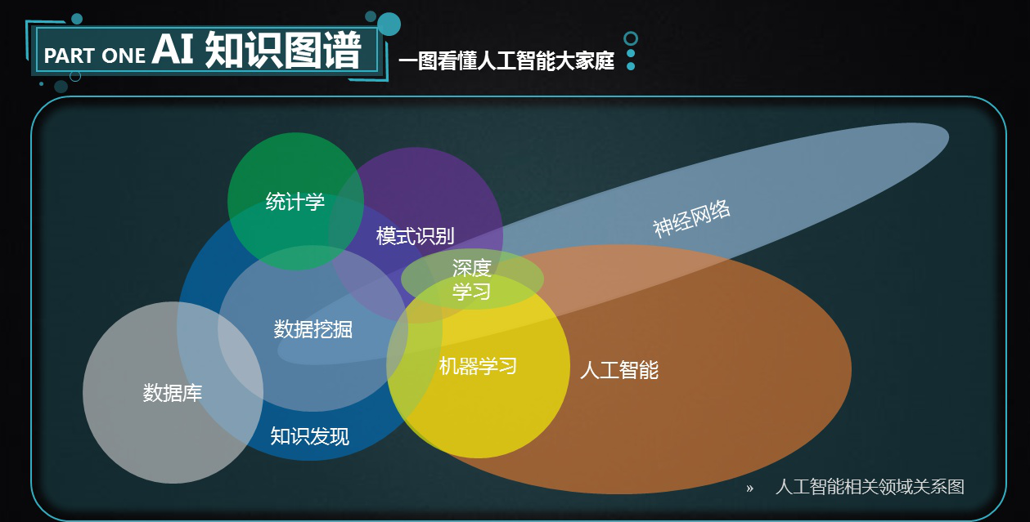

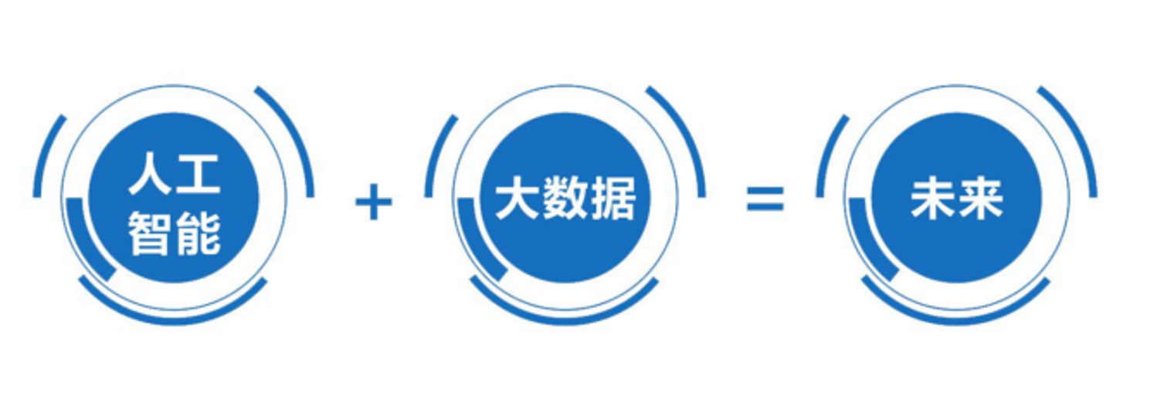

## 发展历史

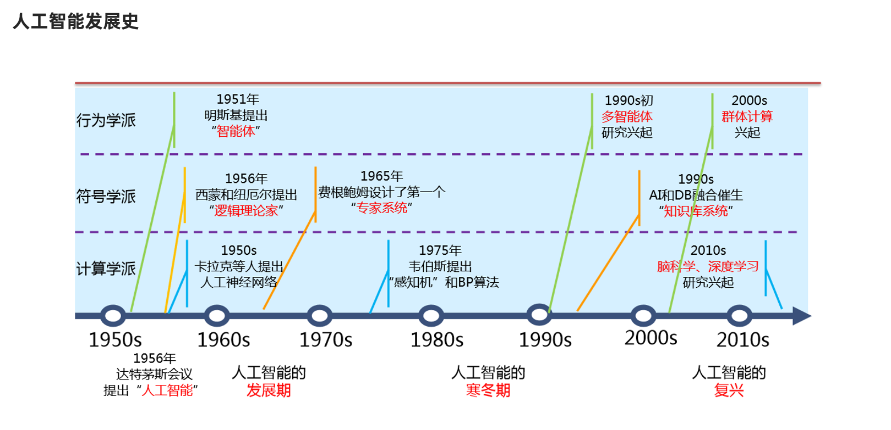

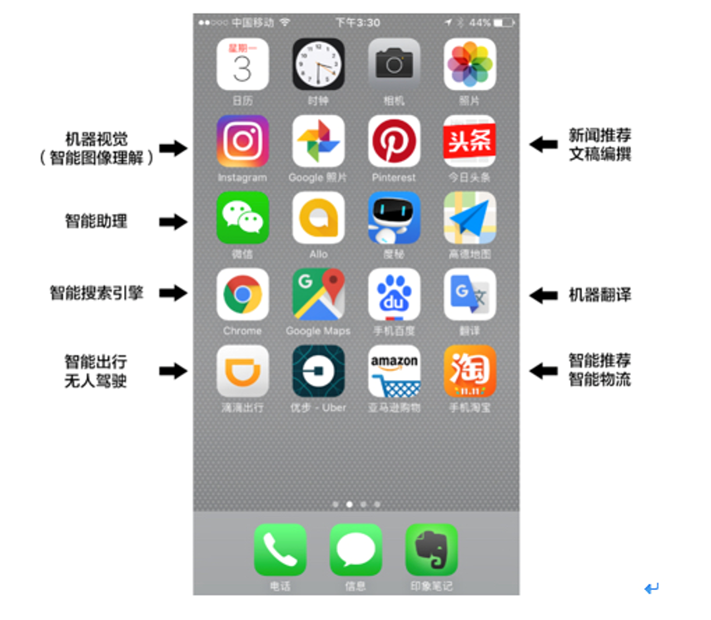

## 什么是机器学习

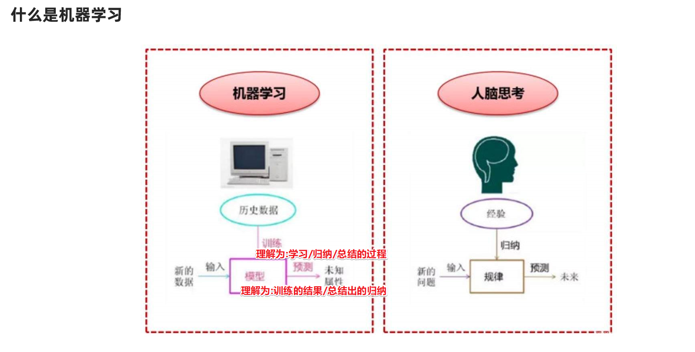

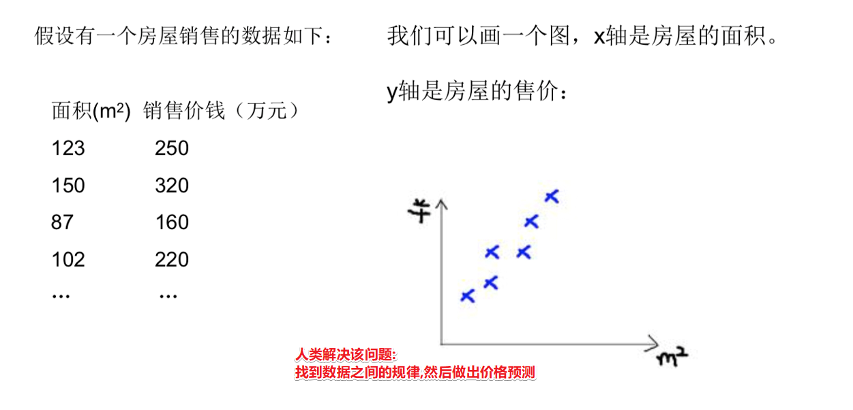

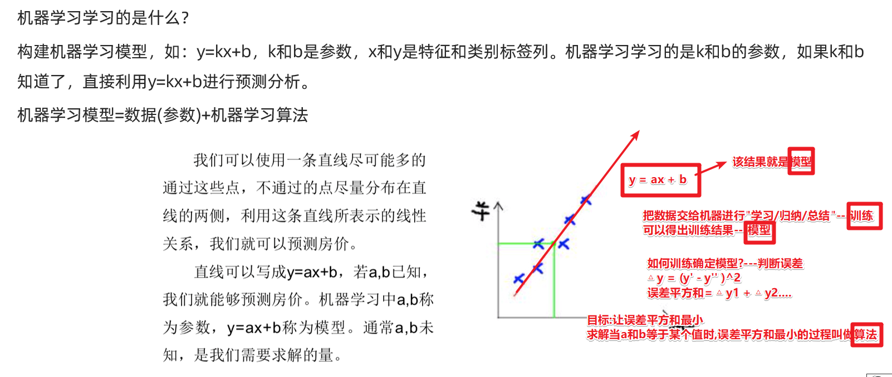

总结:

==机器学习: 给机器大量的数据 进行 训练 并使用数学算法进行求解 得出模型!==

==机器学习的本质: 就是数学==

==机器学习 = 数据 + 数学算法---> 训练出 模型 然后做预测/判断==

## 机器学习专业术语

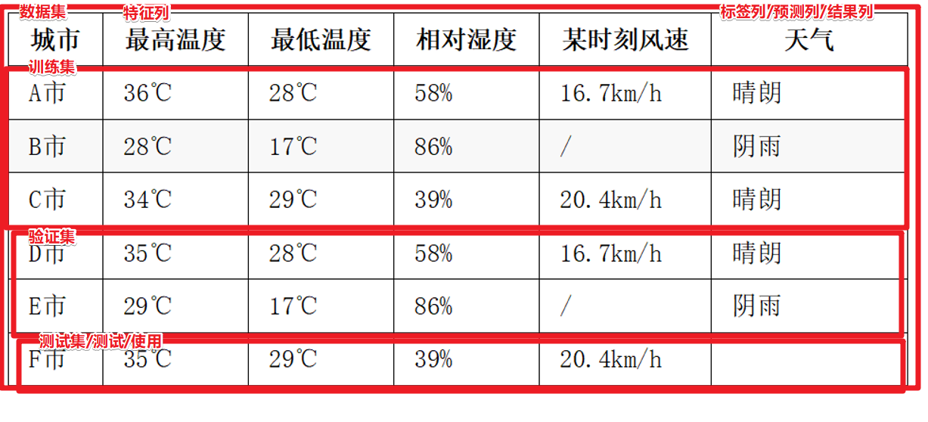

## 机器学习的分类

有监督学习:有标签列, 房价预测

无监督学习:没有标签列 , 用户聚类分群

强化学习:需要和环境进行交互反馈

....

## 编程语言/框架的选择

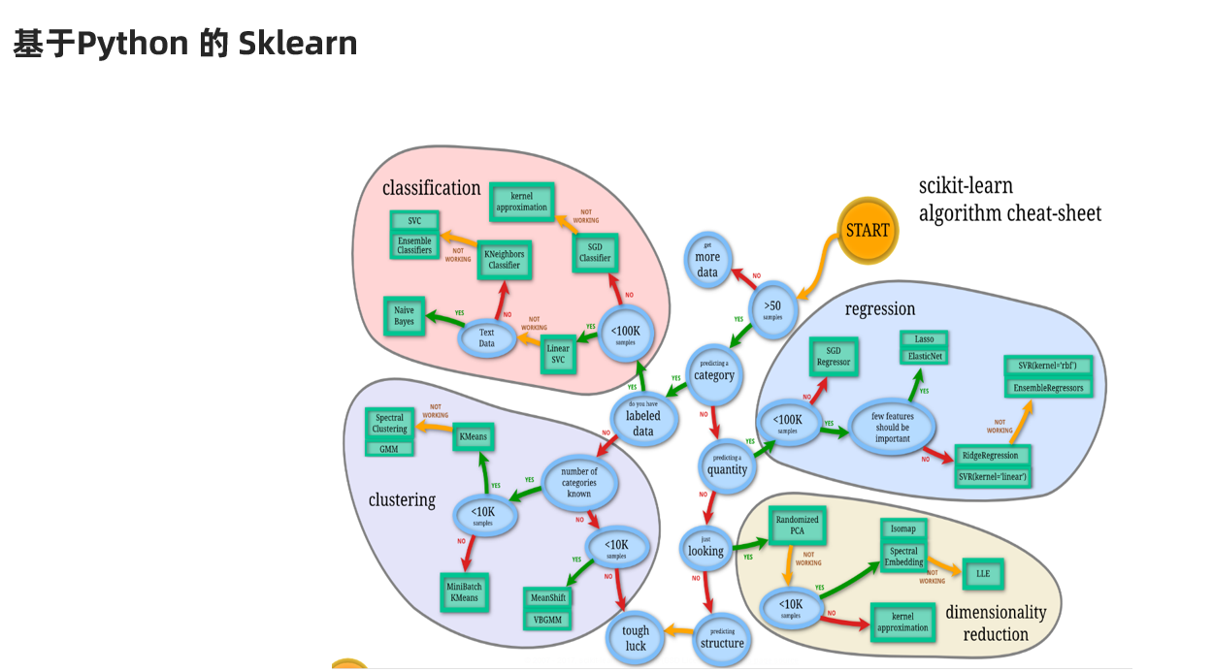

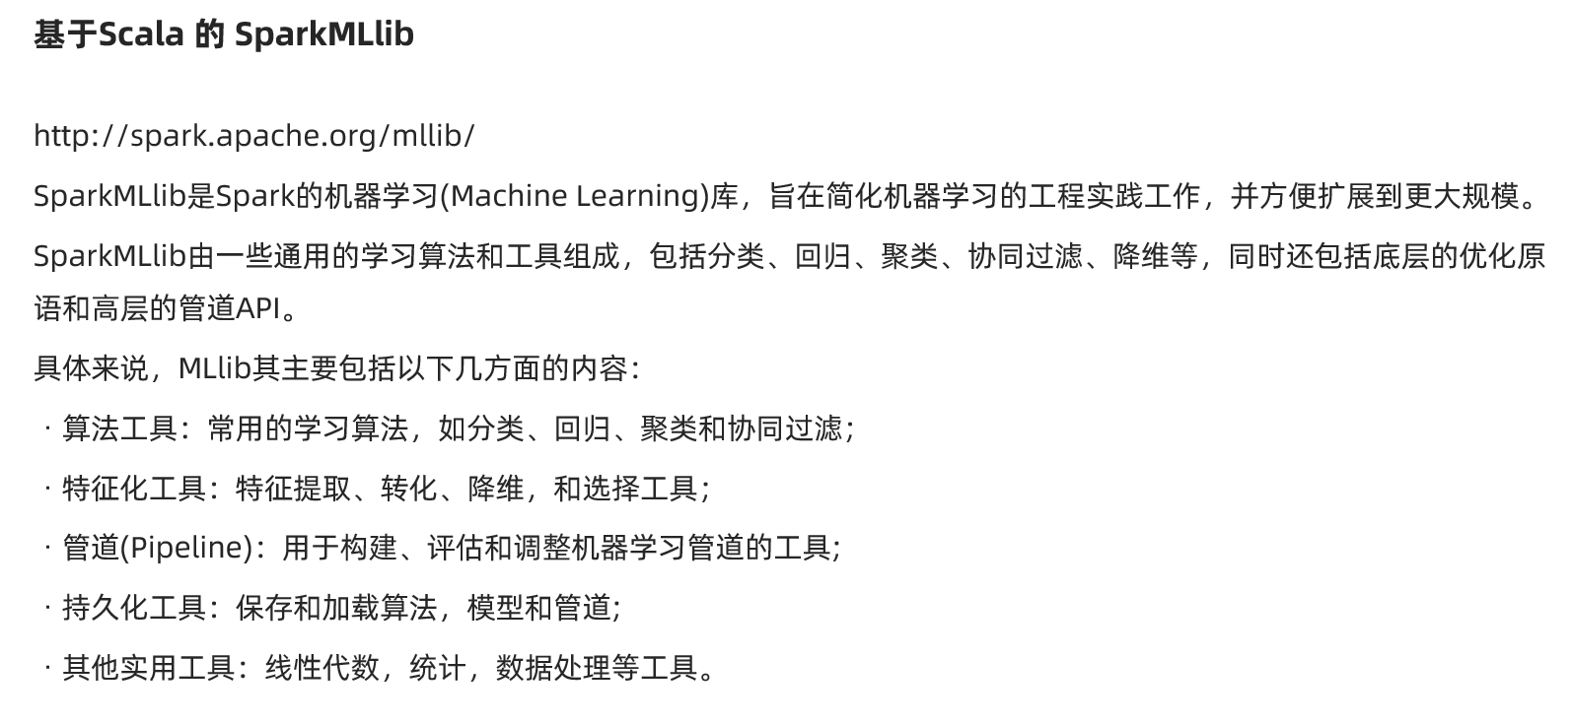

注意:SparkMlLib支持:scala/java/python

# 推荐算法入门

## 推荐系统概述

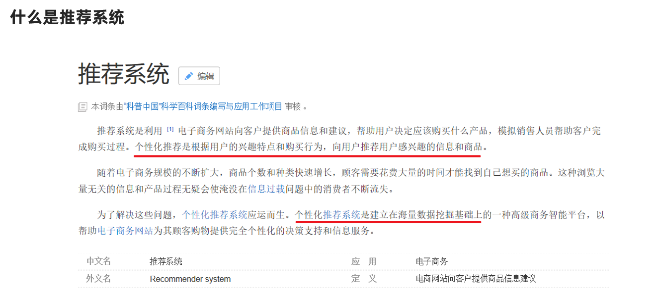

推荐系统: 数据 + 挖掘/训练 ---> 模型/用户的兴趣爱好等特征---> 给用户做推荐

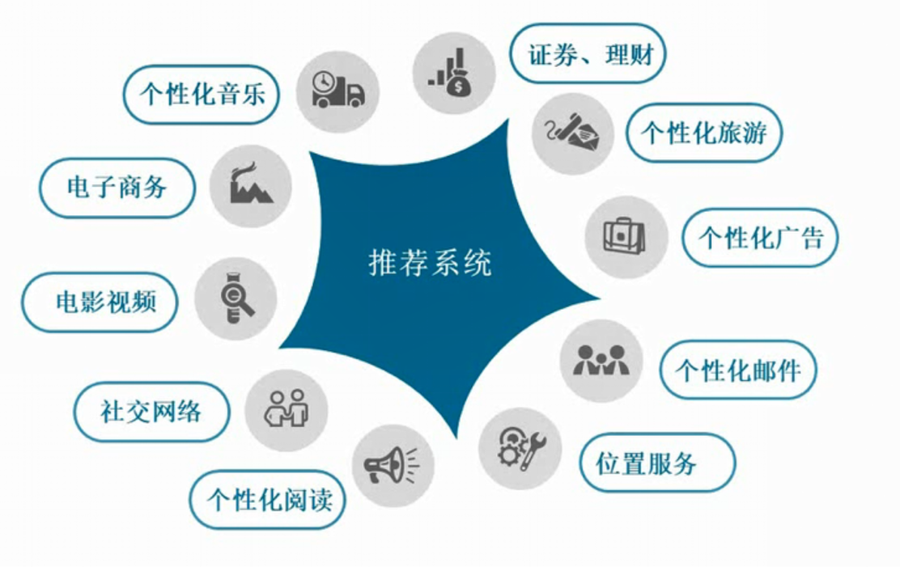

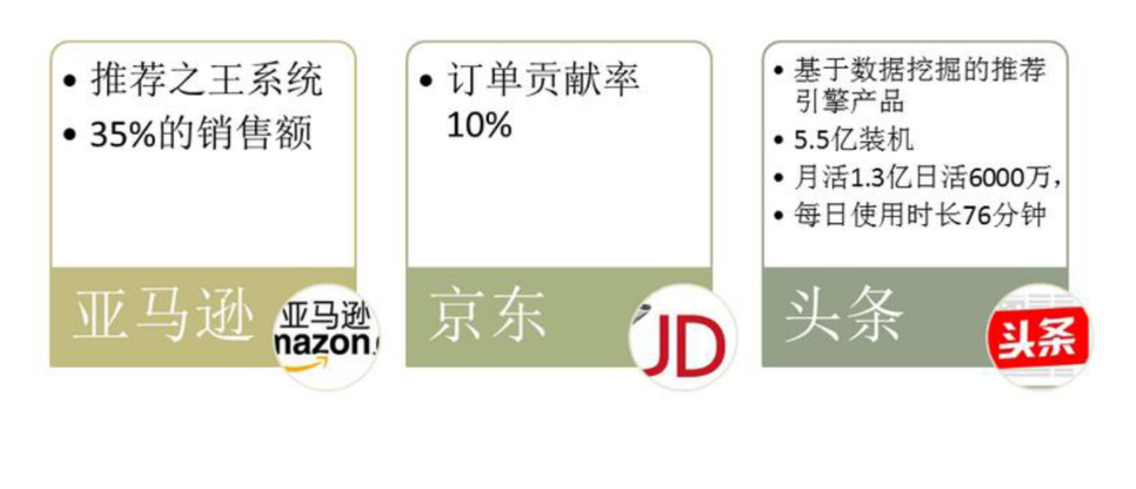

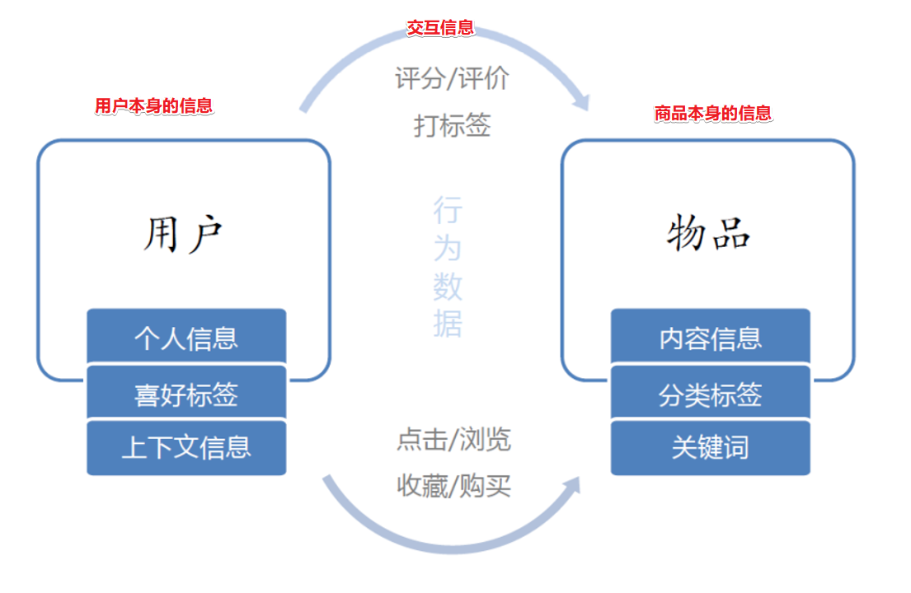

## 推荐算法-分类

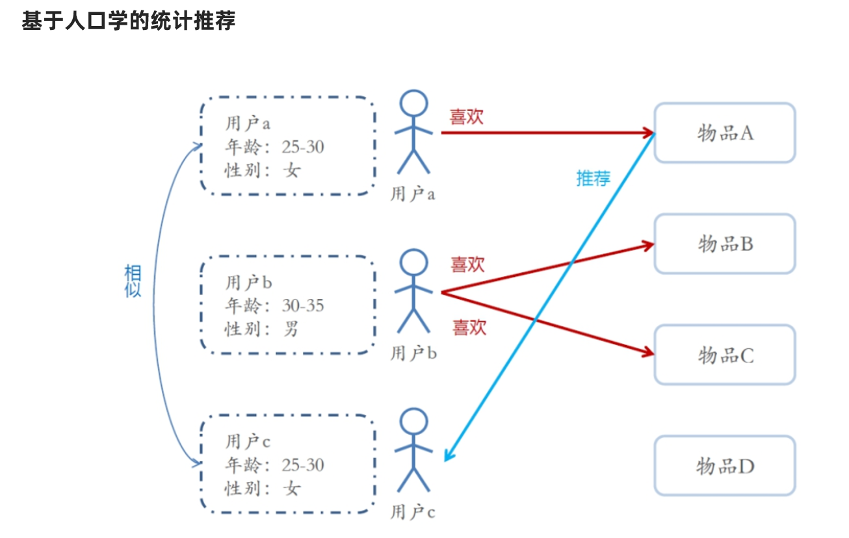

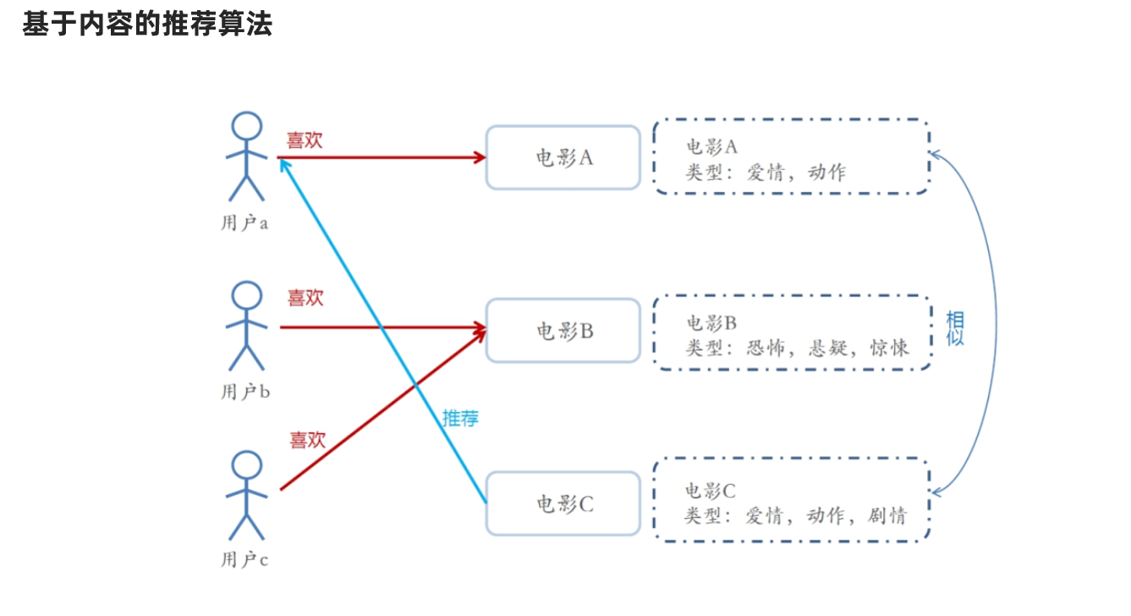

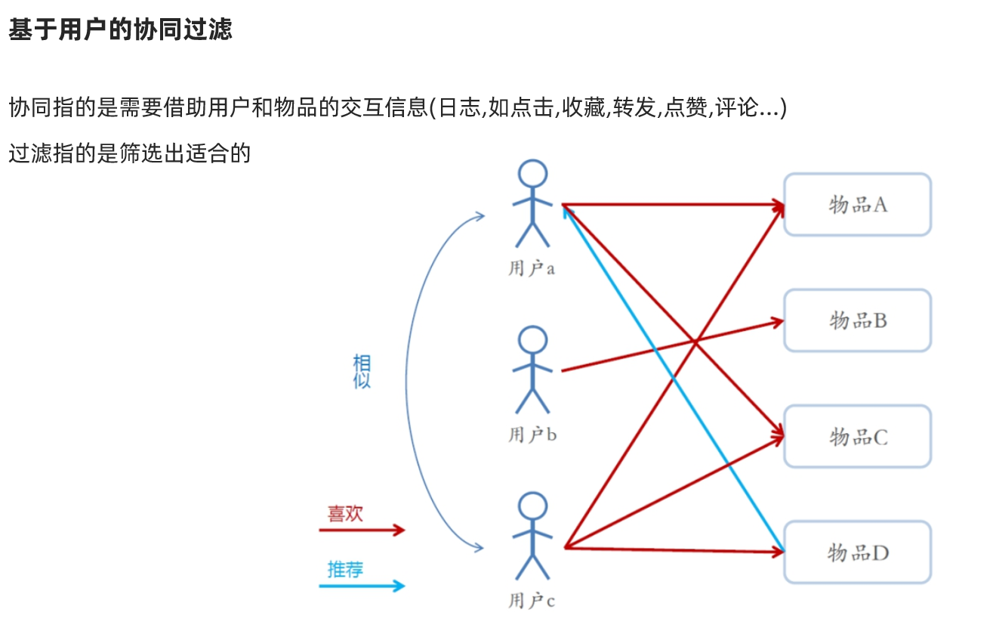

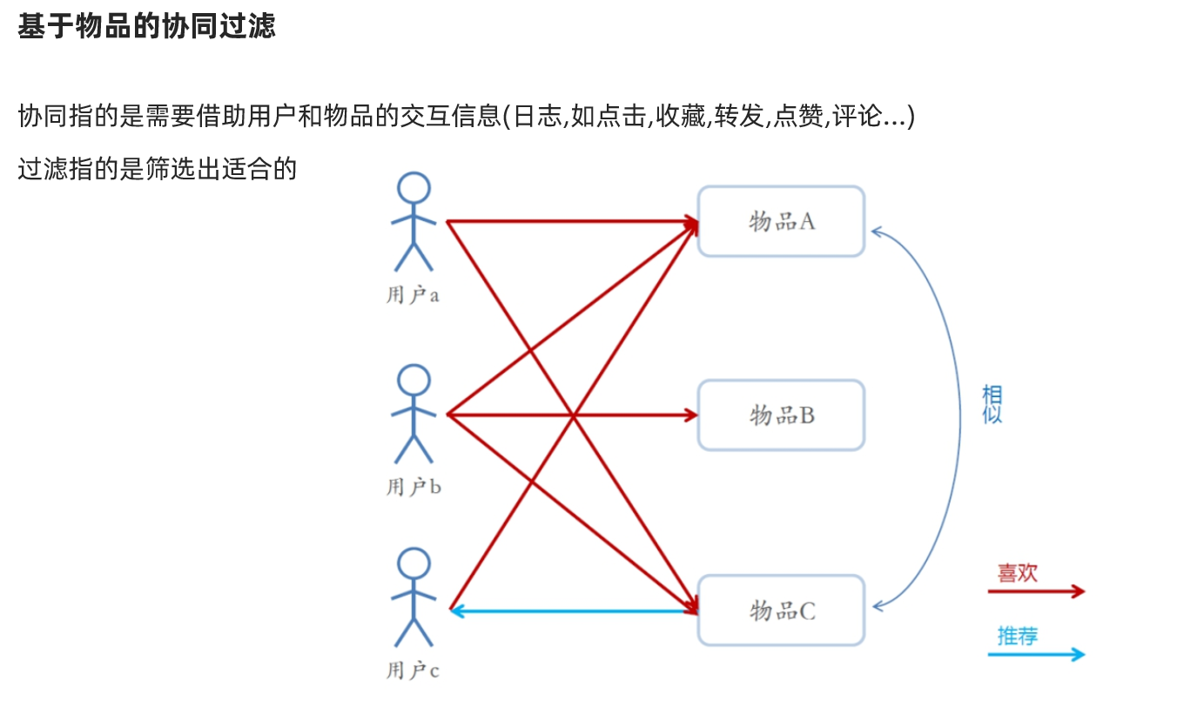

## ALS算法详解

### 数学基础

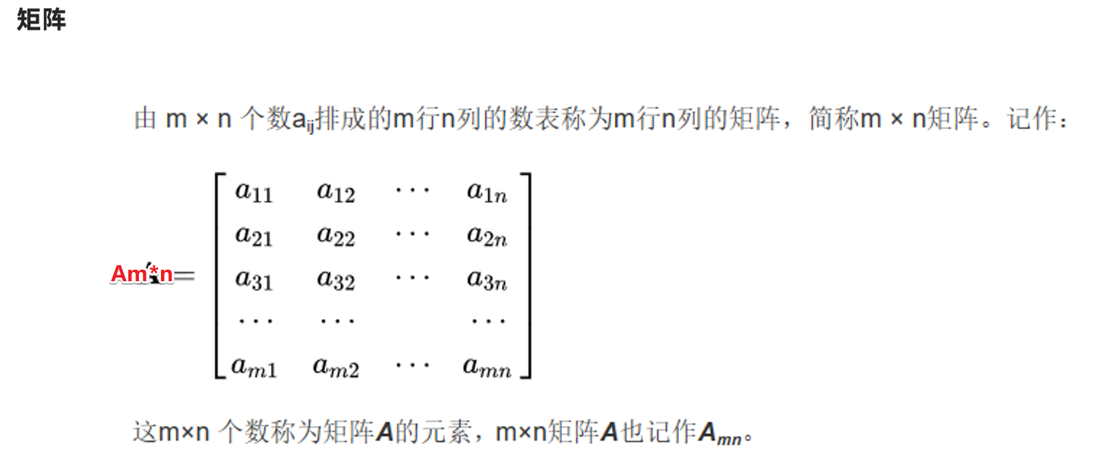

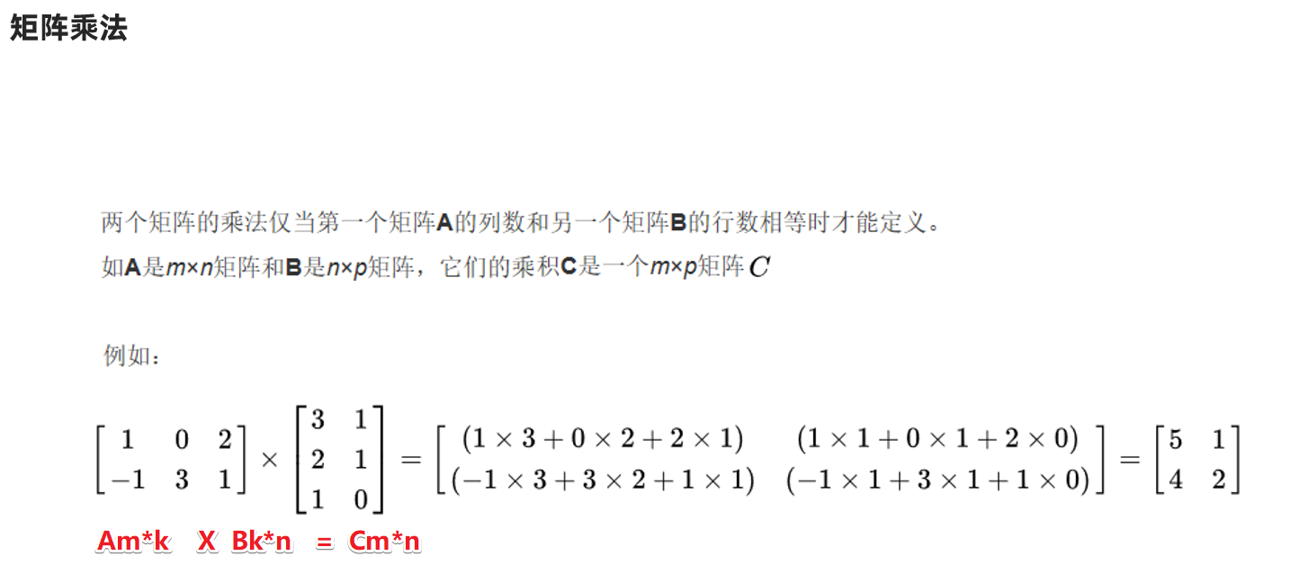

总结:

Am*k X Bk*n = Cm*n ----至于乘法的规则,是数学问题, 知道可以乘即可,不需要我们自己计算  
反过来  
Cm*n = Am*k X Bk*n ----至于矩阵如何拆分/如何分解,是数学问题,知道可以拆/可以分解即可

### 需求

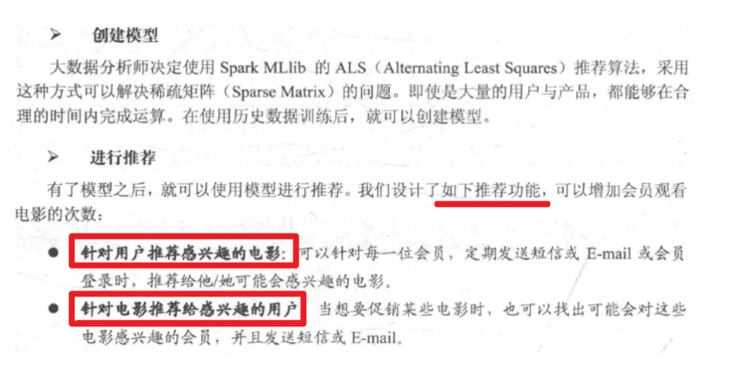

### 数据

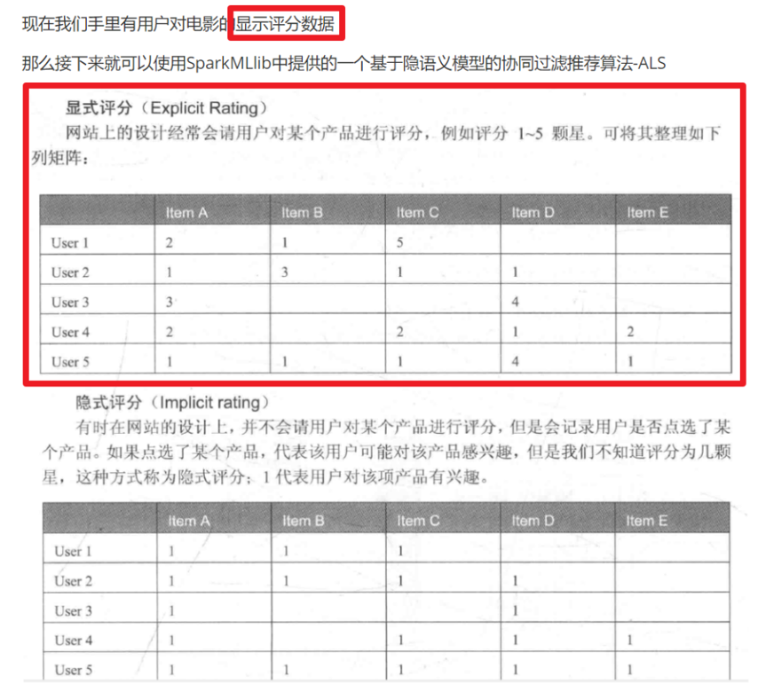

### 思路

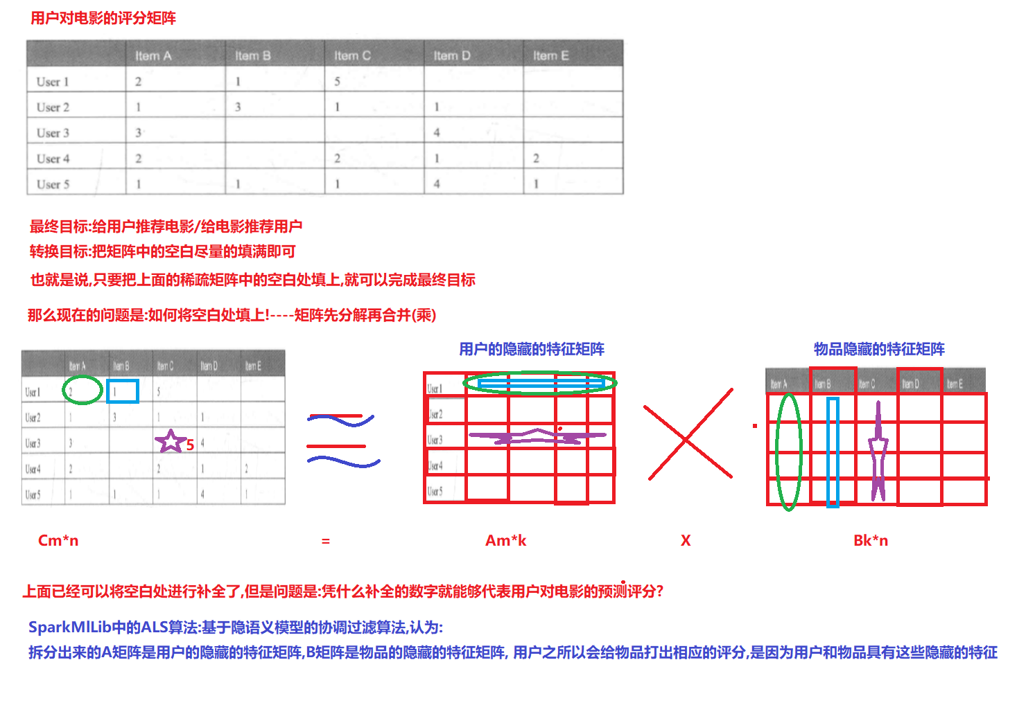

总结:

使用SparkMllib中提供的基于隐语义模型的协同过滤算法-ALS算法就可以实现该需求!

### 代码实现

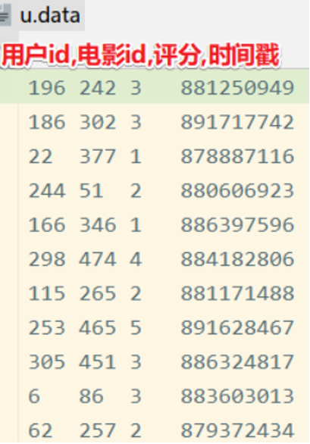

package com.as.edu.model  
  
import org.apache.spark.SparkContext  
import org.apache.spark.ml.recommendation.{ALS, ALSModel}  
import org.apache.spark.sql.{DataFrame, Dataset, Row, SparkSession}  
  
/**  
 * Author roy  
 * Desc   
 */  
object ALSMovieDemoTest {  
 def main(args: Array[String]): Unit = {  
 //TODO 0.准备环境  
 val spark: SparkSession = SparkSession.builder().appName("BatchAnalysis").master("local[*]")  
 .config("spark.sql.shuffle.partitions", "4")//本次测试时将分区数设置小一点,实际开发中可以根据集群规模调整大小,默认200  
 .getOrCreate()  
 val sc: SparkContext = spark.sparkContext  
 sc.setLogLevel("WARN")  
 import spark.implicits._  
 import org.apache.spark.sql.functions._  
  
 //TODO 1.加载数据并处理  
 val fileDS: Dataset[String] = spark.read.textFile("data/input/u.data")  
 val ratingDF: DataFrame = fileDS.map(line => {  
 val arr: Array[String] = line.split("\t")  
 (arr(0).toInt, arr(1).toInt, arr(2).toDouble)  
 }).toDF("userId", "movieId", "score")  
  
 val Array(trainSet,testSet) = ratingDF.randomSplit(Array(0.8,0.2))//按照8:2划分训练集和测试集  
  
 //TODO 2.构建ALS推荐算法模型并训练  
 val als: ALS = new ALS()  
 .setUserCol("userId") //设置用户id是哪一列  
 .setItemCol("movieId") //设置产品id是哪一列  
 .setRatingCol("score") //设置评分列  
 .setRank(10) //可以理解为Cm*n = Am*k X Bk*n 里面的k的值  
 .setMaxIter(10) //最大迭代次数  
 .setAlpha(1.0)//迭代步长  
  
 //使用训练集训练模型  
 val model: ALSModel = als.fit(trainSet)  
  
 //使用测试集测试模型  
 //val testResult: DataFrame = model.recommendForUserSubset(testSet,5)  
 //计算模型误差--模型评估  
 //......  
  
 //TODO 3.给用户做推荐  
 val result1: DataFrame = model.recommendForAllUsers(5)//给所有用户推荐5部电影  
 val result2: DataFrame = model.recommendForAllItems(5)//给所有电影推荐5个用户  
  
 val result3: DataFrame = model.recommendForUserSubset(sc.makeRDD(Array(196)).toDF("userId"),5)//给指定用户推荐5部电影  
 val result4: DataFrame = model.recommendForItemSubset(sc.makeRDD(Array(242)).toDF("movieId"),5)//给指定电影推荐5个用户  
  
 result1.show(false)  
 result2.show(false)  
 result3.show(false)  
 result4.show(false)  
 }  
}